

**ASSIGNMENT 02**

**KANWAL SHEHZADI-------------------------------------------------02-131212-027**



**ASSIGNMENT 02**

1. **Write a program to display a well come to bahria in LCD display**

**PROGRAM:**

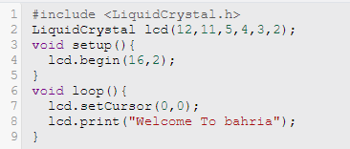

**CIRCUIT:**

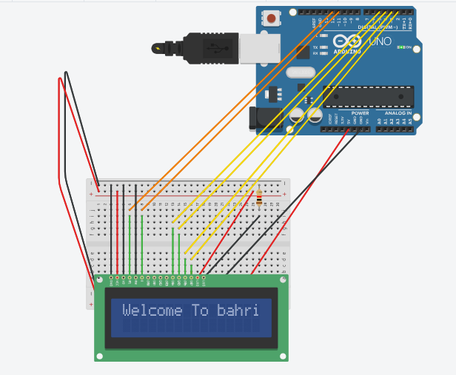

1. **Draw the Block diagram of seven segment display and write its code in C and Assembly**

**C PROGRAM:**

void setup()

{

pinMode(2, OUTPUT);

pinMode(3, OUTPUT);

pinMode(4, OUTPUT);

pinMode(5, OUTPUT);

pinMode(6, OUTPUT);

pinMode(7, OUTPUT);

pinMode(8, OUTPUT);

pinMode(9, OUTPUT);

pinMode(0, OUTPUT);

}

void loop()

{

digitalWrite(2, LOW);

digitalWrite(3, HIGH);

digitalWrite(4, HIGH);

digitalWrite(5, HIGH);

digitalWrite(6, HIGH);

digitalWrite(7, HIGH);

digitalWrite(8, HIGH);

digitalWrite(9, LOW);

delay(2000); // Wait for 2000 millisecond(s)

digitalWrite(2, LOW);

digitalWrite(3, HIGH);

digitalWrite(4, LOW);

digitalWrite(5, LOW);

digitalWrite(6, HIGH);

digitalWrite(7, LOW);

digitalWrite(8, LOW);

digitalWrite(9, LOW);

delay(2000); // Wait for 2000 millisecond(s)

digitalWrite(2, LOW);

digitalWrite(3, LOW);

digitalWrite(4, HIGH);

digitalWrite(5, HIGH);

digitalWrite(6, HIGH);

digitalWrite(7, HIGH);

digitalWrite(8, LOW);

digitalWrite(9, HIGH);

delay(2000); // Wait for 2000 millisecond(s)

digitalWrite(2, LOW);

digitalWrite(3, HIGH);

digitalWrite(4, HIGH);

digitalWrite(5, LOW);

digitalWrite(6, HIGH);

digitalWrite(7, HIGH);

digitalWrite(8, LOW);

digitalWrite(9, HIGH);

delay(2000); // Wait for 2000 millisecond(s)

digitalWrite(2, LOW);

digitalWrite(3, HIGH);

digitalWrite(4, LOW);

digitalWrite(5, LOW);

digitalWrite(6, HIGH);

digitalWrite(7, LOW);

digitalWrite(8, HIGH);

digitalWrite(9, HIGH);

delay(2000); // Wait for 2000 millisecond(s)

digitalWrite(2, LOW);

digitalWrite(3, HIGH);

digitalWrite(4, HIGH);

digitalWrite(5, LOW);

digitalWrite(6, LOW);

digitalWrite(7, HIGH);

digitalWrite(8, HIGH);

digitalWrite(9, HIGH);

delay(2000); // Wait for 2000 millisecond(s)

digitalWrite(2, LOW);

digitalWrite(3, HIGH);

digitalWrite(4, HIGH);

digitalWrite(5, HIGH);

digitalWrite(6, LOW);

digitalWrite(7, HIGH);

digitalWrite(8, HIGH);

digitalWrite(0, HIGH);

delay(1000); // Wait for 1000 millisecond(s)

digitalWrite(2, LOW);

digitalWrite(3, HIGH);

digitalWrite(4, LOW);

digitalWrite(5, LOW);

digitalWrite(6, HIGH);

digitalWrite(7, HIGH);

digitalWrite(8, LOW);

digitalWrite(9, LOW);

delay(2000); // Wait for 2000 millisecond(s)

digitalWrite(2, LOW);

digitalWrite(3, HIGH);

digitalWrite(4, HIGH);

digitalWrite(5, HIGH);

digitalWrite(6, HIGH);

digitalWrite(7, HIGH);

digitalWrite(8, HIGH);

digitalWrite(9, HIGH);

delay(2000); // Wait for 2000 millisecond(s)

digitalWrite(2, LOW);

digitalWrite(3, HIGH);

digitalWrite(4, HIGH);

digitalWrite(5, LOW);

digitalWrite(6, HIGH);

digitalWrite(7, HIGH);

digitalWrite(8, HIGH);

digitalWrite(9, HIGH);

delay(2000); // Wait for 2000 millisecond(s)

digitalWrite(2, HIGH);

digitalWrite(3, LOW);

digitalWrite(4, LOW);

digitalWrite(5, LOW);

digitalWrite(6, LOW);

digitalWrite(7, LOW);

digitalWrite(8, LOW);

digitalWrite(9, LOW);

delay(2000); // Wait for 2000 millisecond(s)

}

**CIRCUIT:**

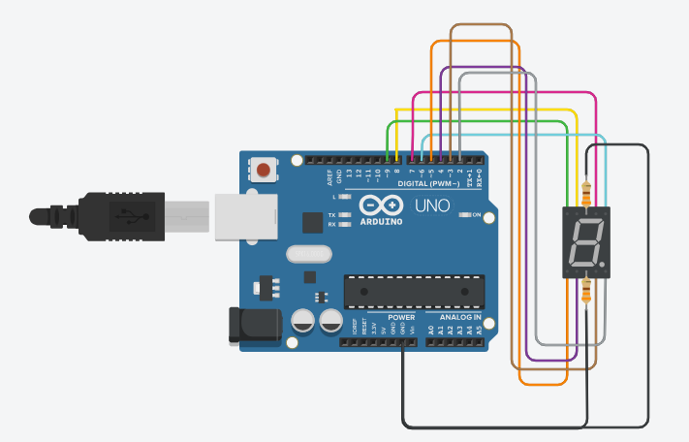

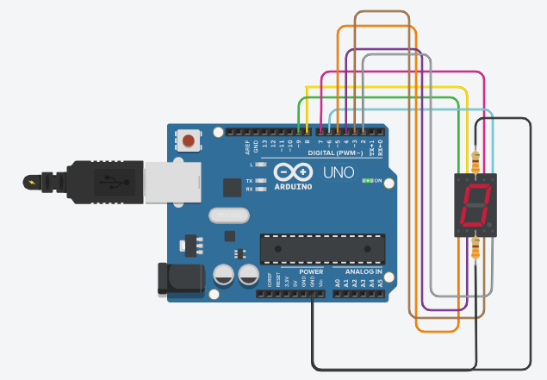 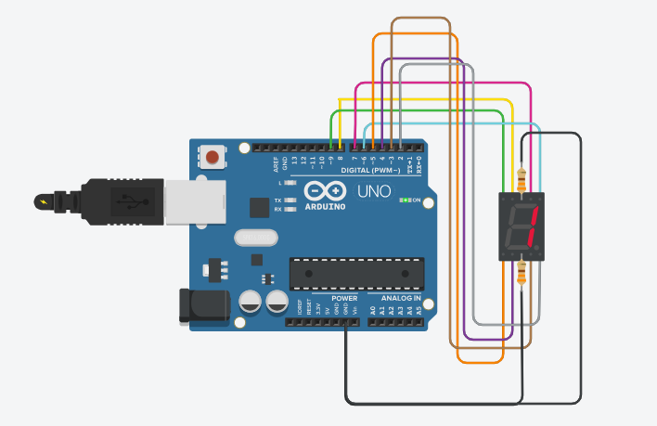

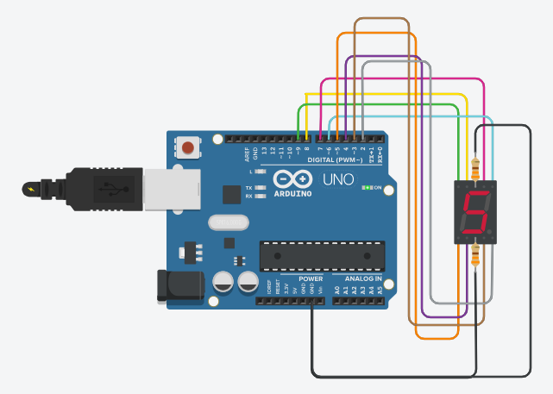 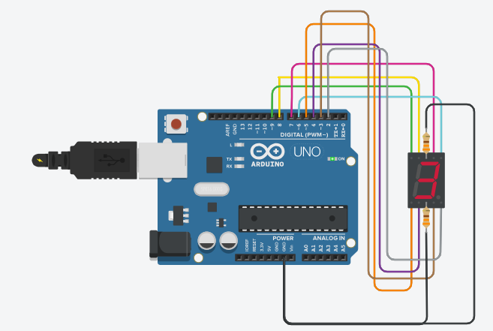

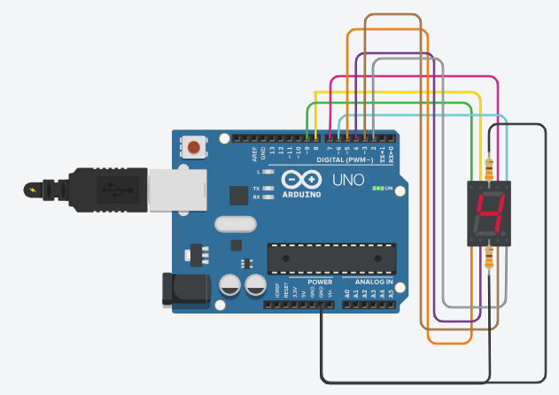 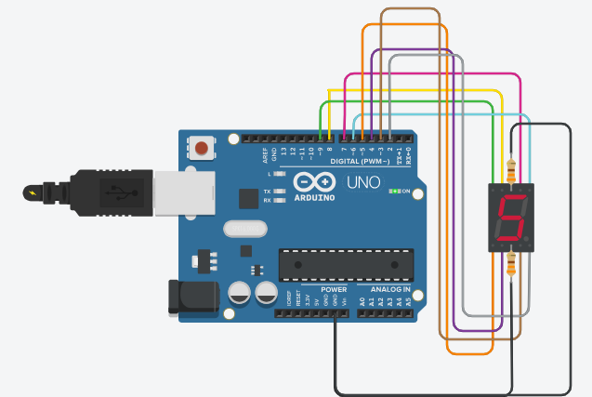

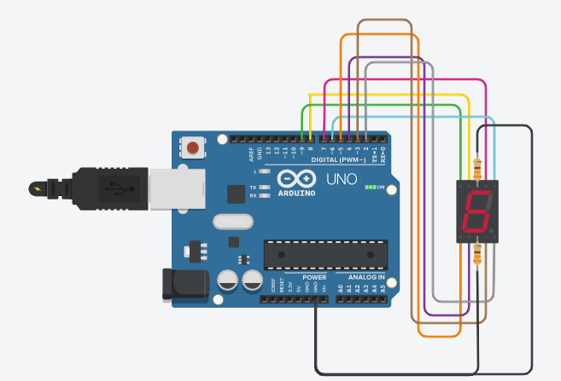 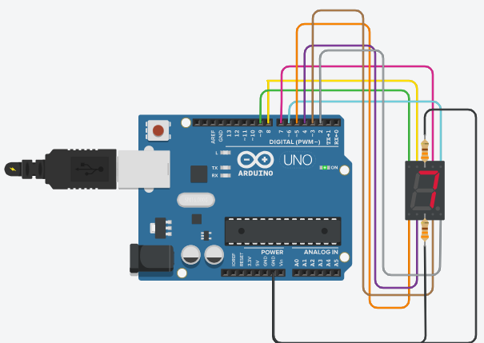

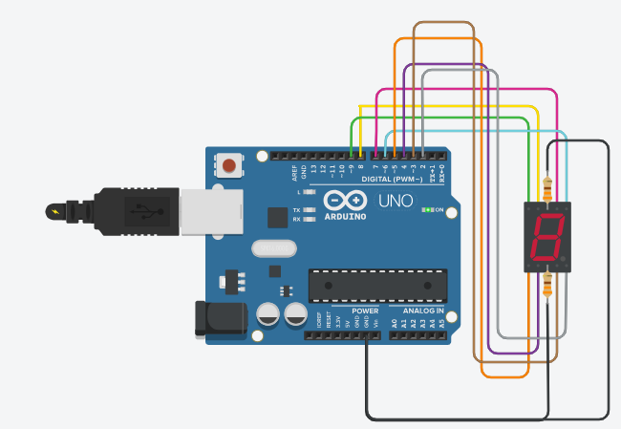 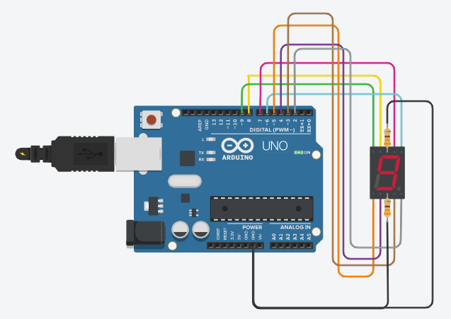

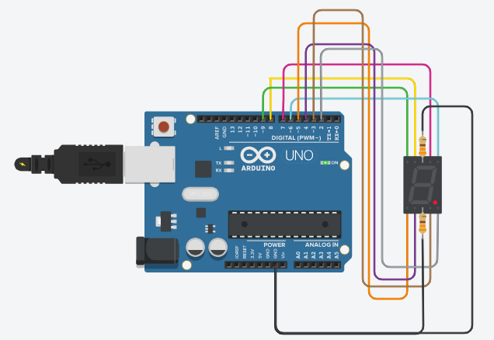

**ASSEMBLY PROGRAM:**

**.**include "m328pdef.inc"

// Define constants for port addresses

.equ SEG_PORT = PORTD

.equ DELAY = 2000 // Delay in milliseconds

.global main

main:

; Initialize port D for output

ldi r16, 0xFF

out SEG_PORT, r16

loop:

; Display '1'

ldi r16, 0b11111100

out SEG_PORT, r16

call delay_ms

out SEG_PORT, r16

call delay_ms

; Display '2'

ldi r16, 0b01100000

out SEG_PORT, r16

call delay_ms

out SEG_PORT, r16

call delay_ms

; Display '3'

ldi r16, 0b11011010

out SEG_PORT, r16

call delay_ms

out SEG_PORT, r16

call delay_ms

; Add code for displaying other digits

rjmp loop

delay_ms:

ldi r18, 250 ; Initialize outer loop counter

outer_loop:

ldi r17, 184 ; Initialize inner loop counter

inner_loop:

dec r17

brne inner_loop

dec r18

brne outer_loop

ret

.end

1. **Draw block diagram of two seven segment display**

**Write a program in Assembly and C to display a digit from 0 to 9 in both seven segment display**

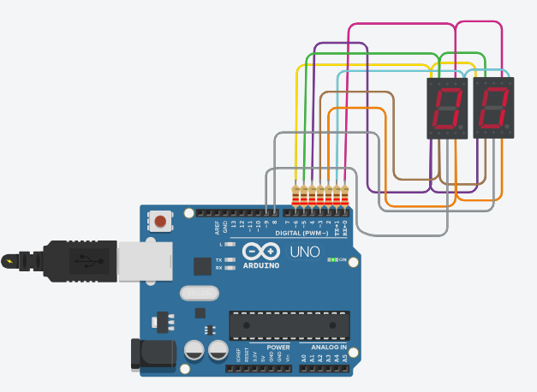 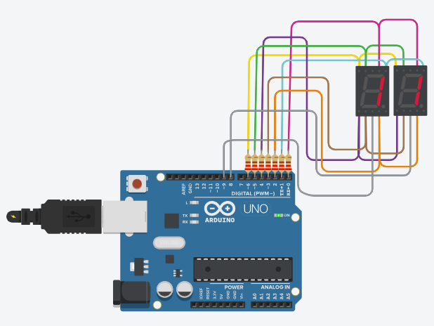

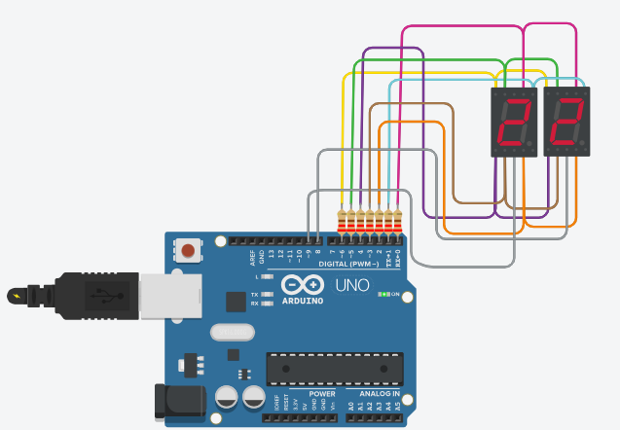 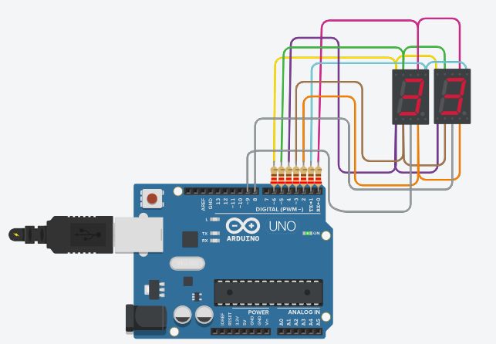

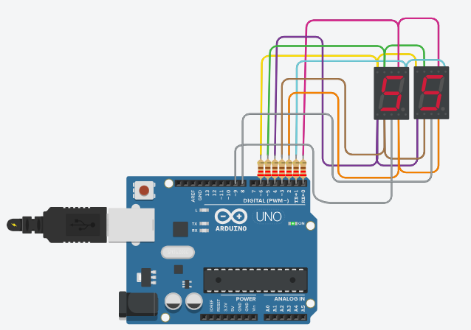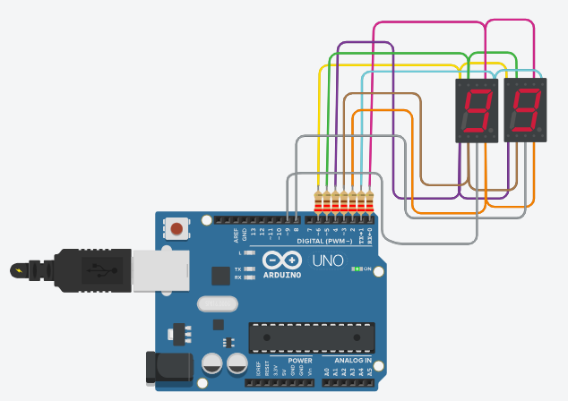

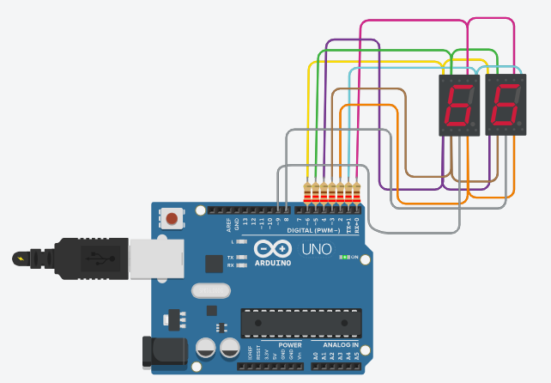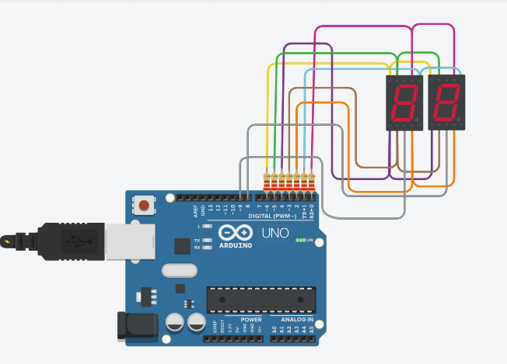

**C PROGRAM:** //a,b,c,d,e,f,g

byte segValue[10][7] = {

{0,0,0,0,0,0,1}, //0

{1,0,0,1,1,1,1}, //1

{0,0,1,0,0,1,0}, //2

{0,0,0,0,1,1,0}, //3

{1,0,0,1,1,0,0}, //4

{0,1,0,0,1,0,0}, //5

{0,1,0,0,0,0,0}, //6

{0,0,0,1,1,1,1}, //7

{0,0,0,0,0,0,0}, //8

{0,0,0,0,1,0,0} //9

};

byte segPin[8]={2,3,4,5,6,7,8,9}; //{a,b,c,d,e,f,g,dp}

byte digitPin[2] = {A0,A1}; //segment

void setup() {

for(int i=0;i<10;i++){

pinMode(segPin[i], OUTPUT);

}

pinMode(digitPin[0], OUTPUT);

pinMode(digitPin[1], OUTPUT);

digitalWrite(digitPin[0], LOW);

digitalWrite(digitPin[1], LOW);

}

void loop()

{

for (int i = 0; i<100; i++)

{

display_N(i);

delay(1);

}

}

void display_N(int num)

{

// Convierte unidades y decenas

int und = num % 10;

int dec = (num % 100) / 10;

// Refresco dinamico

for(int i=0; i<100; i++)

{

segOutput(1, und, 1);

segOutput(0, dec, 1);

delay(2);

}

Serial.print(dec);

Serial.println(und);

}

//LED

void segClear(){

for(int i=0;i<8;i++){

digitalWrite(segPin[i], HIGH);

}

}

//LED

void segOutput(int d, int Number, int dp){

segClear();

digitalWrite(digitPin[d], HIGH);

for(int i=0;i<7;i++){

digitalWrite(segPin[i], segValue[Number][i]);

}

digitalWrite(segPin[7], dp);

delayMicroseconds(1000);

digitalWrite(digitPin[d], LOW);

}

**ASSEMBLY PROGRAM:**

#define A 0

#define B 1

#define C 2

#define D 3

#define E 4

#define F 5

#define G 6

#define DIGIT1 9

#define DIGIT2 8

.data

myNumber: .byte 0b0111111, 0b0000110, 0b1011011, 0b1001111, 0b1100110, 0b1101101, 0b1111101, 0b0000111, 0b1111111, 0b1101111

.text

.global main

main:

ldi count, 0 ; Initialize count to 0

loop:

; Display "0" on the right display (digit2)

ldi r16, LOW(DIGIT1)

out PORTB, r16 ; Set digit1 pin low

ldi r16, 0x00 ; Clear display

out PORTA, r16 ; Set all segment pins low

ldi r16, myNumber

add r16, count

ld r17, X

out PORTA, r17 ; Display the current number

ldi r16, 0x01 ; Set digit2 pin high

out PORTB, r16

; Delay

ldi r16, 250

ldi r17, 5

delay_loop:

dec r17

brne delay_loop

dec r16

brne delay_loop

; Increment count

inc count

cpi count, 10

breq reset_count

; Repeat the loop

rjmp loop

reset_count:

ldi count, 0

; Repeat the loop

rjmp loop

**THE END**